**TASK 2**

According to me AI assistant reduces human efforts by suggesting and answering some general questions. And it cannot replace a human for sure. But still there are ways to make it better each time by just doing user analysis and getting user experience feedback.

Here are some suggestions or feedback to AI assistant of WD.

1. The AI assistant must pick the words from the questions asked search for matching word answer.

For example. Upon asked can you help me with WordPress theme for building website.

AI assistant is replying: Definitely, I am here to help. Ask me anything about your website or app and I will try to answer to the best of my knowledge!

Here is A SCREEN Shot for the chat:

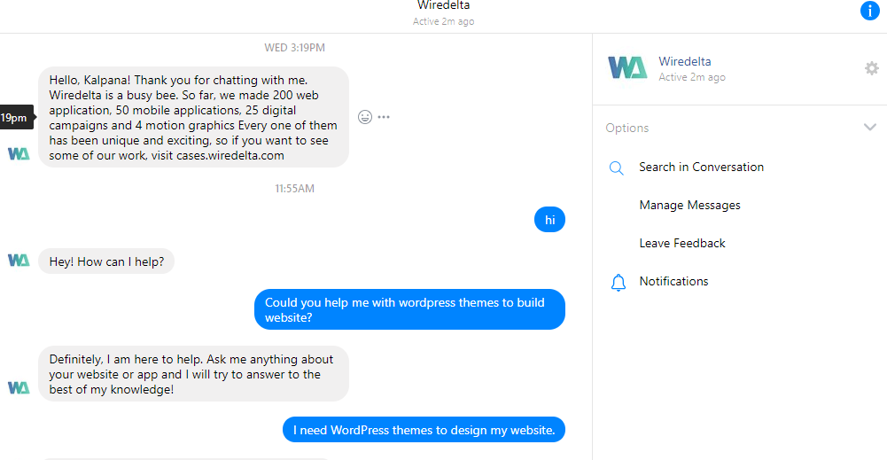

Suggestion to AI Assistant: Could possibly search from the database matching word and show results or answer as a link to website or files to read.

1. AI should not quit answering very soon and reply with: “Hmm, I'm not sure about that. Let me get back to you after I check it with my colleague.”

There must be questions out of questions;

Example: If AI do not know or understand “Help me with Drupal themes? “

Answer should be you mean Drupal to design Website? Or similar questions

1. Bot Sometimes takes time to reply and sometimes just do not reply anything.

Example:

Me: Yes, want help in building website

Bot: Exciting! Have you tried to build a website before?

Me: Yes

Bot: Okay. = > (What does this mean? and then no reply. I was waiting ...)

Me: Are you still there?

Bot: Whenever, wherever

We're meant to be together.

Kidding aside, we are here between 9am and 5pm, and you can find more info on how to contact us on wiredelta.com/contact

* No choice based option if the bot get confused, it can ask me select form following.
* Bot asked me to upload some project documents, I asked whether he needs pdf or ppt. Again same reply like: “Hmm, I'm not sure about that. Let me get back to you after I check it with my colleague.”

## In nutshell, increase knowledge base, add human effort in between, what and how they reply should be an addition. Also needs improvement on sentiment analytics, text analytics.